
Summit Valley School District
Test Reading and Math Performance and Growth
2025-2026 End of Year

Prepared by Drew Vrieze

Data Considerations
- The table below illustrates which students are included in each metric and testing window.
- ELL and CoAlt students are included if they took the diagnostic.
READING K-2 |  | BOY  (Beginning of Year) | MOY  (Middle of Year) | EOY  (End of Year)
Student Grade Level | % Met Grade Level Performance | Includes students who took the assessment during the BOY testing window. | Includes students who took the assessment during the applicable testing window.
 | % Met Annual Typical Growth | Not applicable at BOY, but BOY sets a student’s Annual Typical Growth value. | Includes students who took the assessment during the applicable testing window and had a prior assessment from BOY.

- MOY/EOY Growth is measured from the beginning of the year and is the percentage of students that met 100% of Annual Typical Growth. A change in growth from MOY to EOY indicates whether growth accelerated or decelerated during the second semester.

READING K-2 |  | BOY | MOY | EOY | EOY Target
GRADE K | % Met Grade Level Performance | 43% | 50% | 56% | 63%
 | % Met Annual Typical Growth | N/A | 44% | 50% | 100%
GRADE 1 | % Met Grade Level Performance | 45% | 52% | 58% | 66%
 | % Met Annual Typical Growth | N/A | 46% | 52% | 100%
GRADE 2 | % Met Grade Level Performance | 41% | 47% | 53% | 64%
 | % Met Annual Typical Growth | N/A | 47% | 53% | 100%

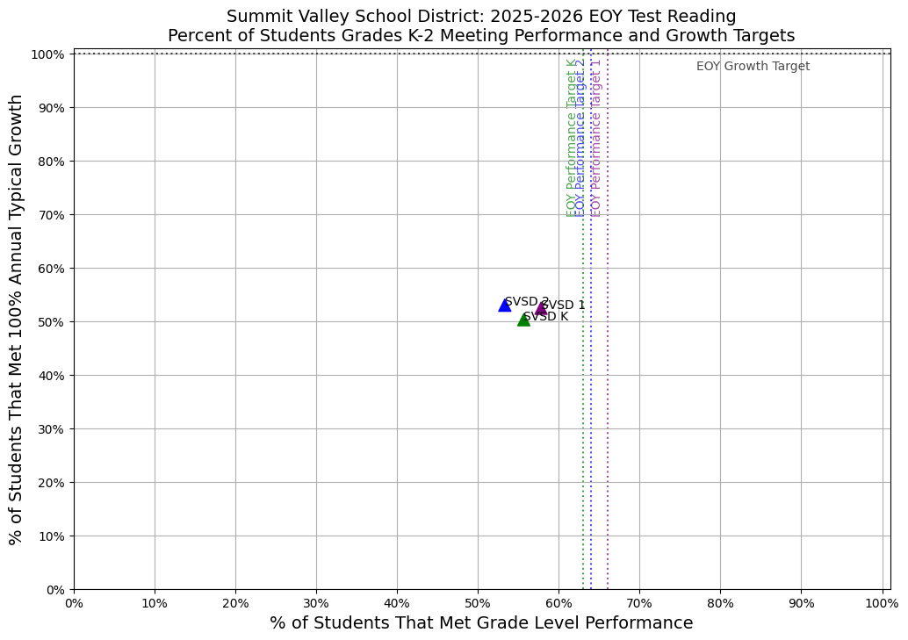

 | Students Met Grade Level Performance (n) | Eligible Students for Performance (n) | Students Met Grade Level Performance (%) | Students Met 100% Annual Typical Growth (n) | Eligible Students for Growth (n) | Students Met 100% Annual Typical Growth (%)
SVSD K | 245 | 440 | 56% | 187 | 372 | 50%
SVSD 1 | 259 | 448 | 58% | 196 | 374 | 52%
SVSD 2 | 232 | 435 | 53% | 196 | 370 | 53%
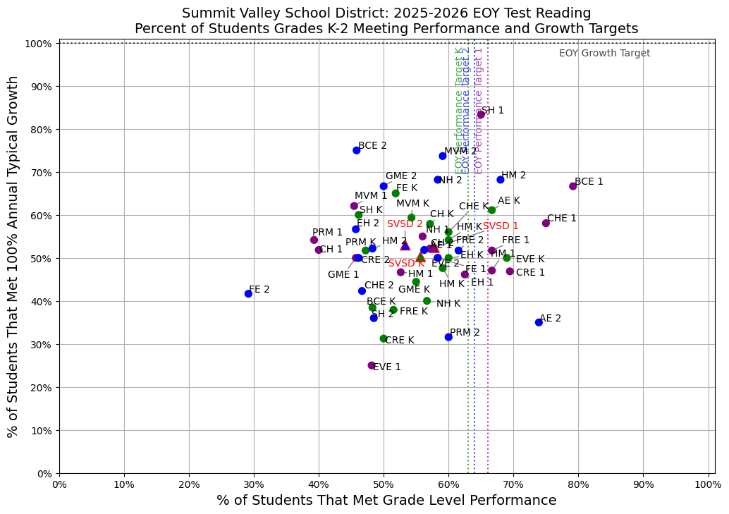
READING 3-5 |  | BOY | MOY | EOY | EOY Target
GRADE 3 | % Met Grade Level Performance | 39% | 46% | 51% | 56%
 | % Met Annual Typical Growth | N/A | 48% | 54% | 100%
GRADE 4 | % Met Grade Level Performance | 48% | 55% | 60% | 58%
 | % Met Annual Typical Growth | N/A | 46% | 52% | 100%
GRADE 5 | % Met Grade Level Performance | 40% | 47% | 53% | 55%
 | % Met Annual Typical Growth | N/A | 47% | 53% | 100%

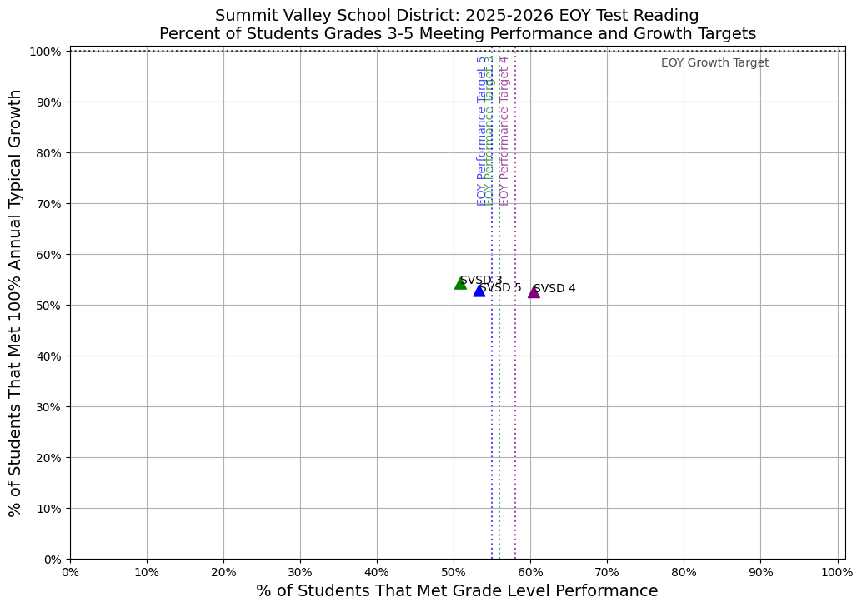
 | Students Met Grade Level Performance (n) | Eligible Students for Performance (n) | Students Met Grade Level Performance (%) | Students Met 100% Annual Typical Growth (n) | Eligible Students for Growth (n) | Students Met 100% Annual Typical Growth (%)
SVSD 3 | 227 | 446 | 51% | 200 | 369 | 54%
SVSD 4 | 269 | 445 | 60% | 190 | 362 | 52%
SVSD 5 | 248 | 465 | 53% | 211 | 400 | 53%
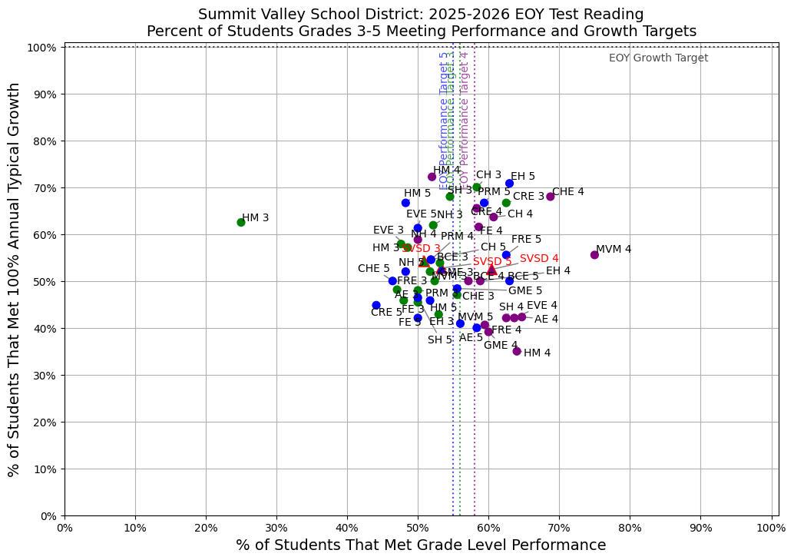
READING 6-8 |  | BOY | MOY | EOY | EOY Target
GRADE 6 | % Met Grade Level Performance | 41% | 48% | 54% | 57%
 | % Met Annual Typical Growth | N/A | 47% | 53% | 100%
GRADE 7 | % Met Grade Level Performance | 46% | 53% | 59% | 54%
 | % Met Annual Typical Growth | N/A | 49% | 54% | 100%
GRADE 8 | % Met Grade Level Performance | 44% | 51% | 57% | 56%
 | % Met Annual Typical Growth | N/A | 42% | 48% | 100%
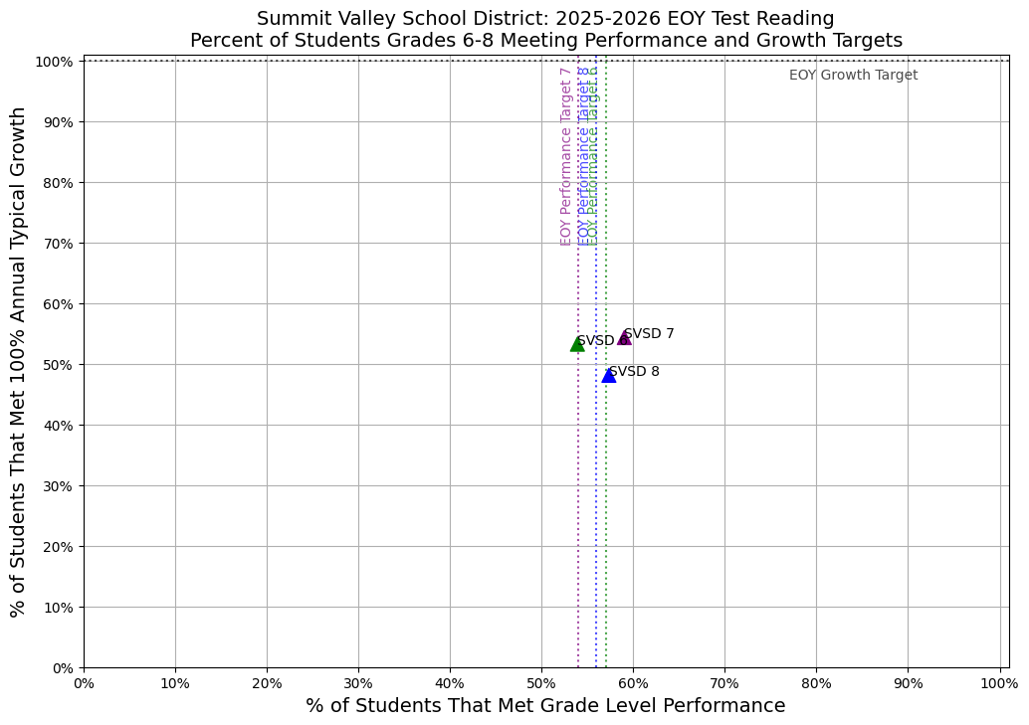
 | Students Met Grade Level Performance (n) | Eligible Students for Performance (n) | Students Met Grade Level Performance (%) | Students Met 100% Annual Typical Growth (n) | Eligible Students for Growth (n) | Students Met 100% Annual Typical Growth (%)
SVSD 6 | 234 | 434 | 54% | 198 | 372 | 53%
SVSD 7 | 281 | 476 | 59% | 214 | 394 | 54%
SVSD 8 | 234 | 408 | 57% | 164 | 341 | 48%
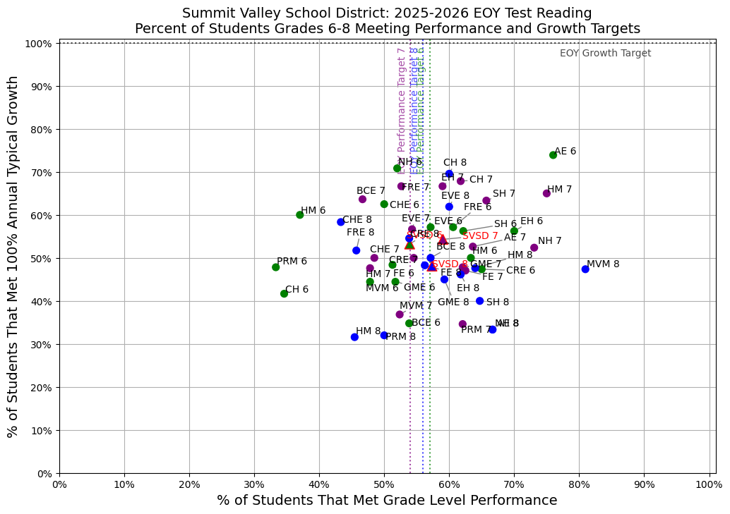
MATH K-2 |  | BOY | MOY | EOY | EOY Target
GRADE K | % Met Grade Level Performance | 38% | 45% | 51% | 60%
 | % Met Annual Typical Growth | N/A | 44% | 50% | 100%
GRADE 1 | % Met Grade Level Performance | 34% | 41% | 46% | 62%
 | % Met Annual Typical Growth | N/A | 43% | 50% | 100%
GRADE 2 | % Met Grade Level Performance | 40% | 47% | 52% | 61%
 | % Met Annual Typical Growth | N/A | 42% | 49% | 100%
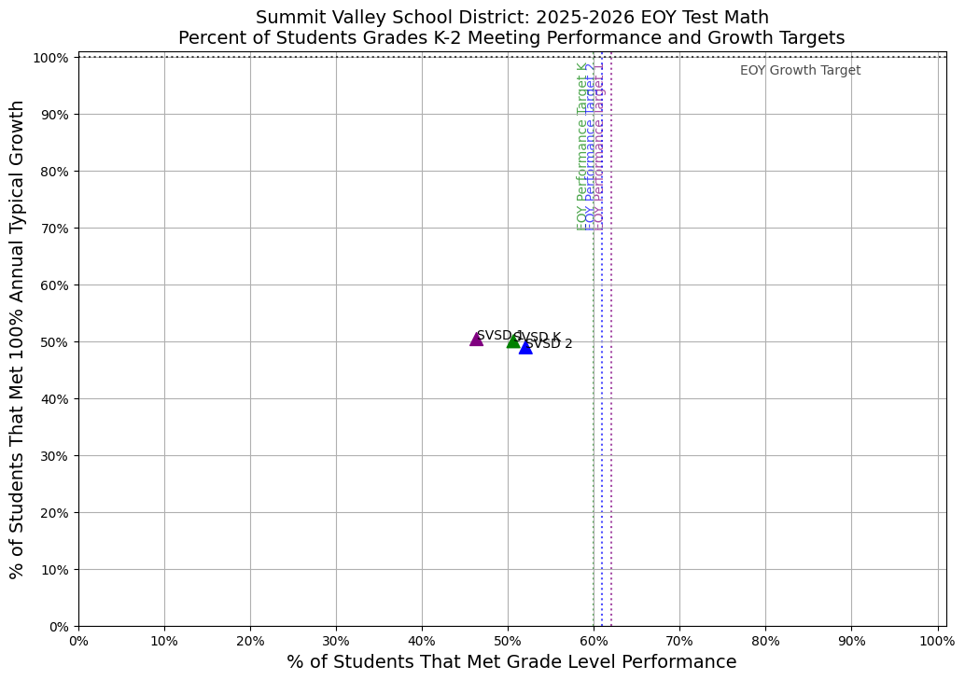
 | Students Met Grade Level Performance (n) | Eligible Students for Performance (n) | Students Met Grade Level Performance (%) | Students Met 100% Annual Typical Growth (n) | Eligible Students for Growth (n) | Students Met 100% Annual Typical Growth (%)
SVSD K | 235 | 464 | 51% | 204 | 408 | 50%
SVSD 1 | 216 | 466 | 46% | 202 | 401 | 50%
SVSD 2 | 226 | 434 | 52% | 185 | 378 | 49%
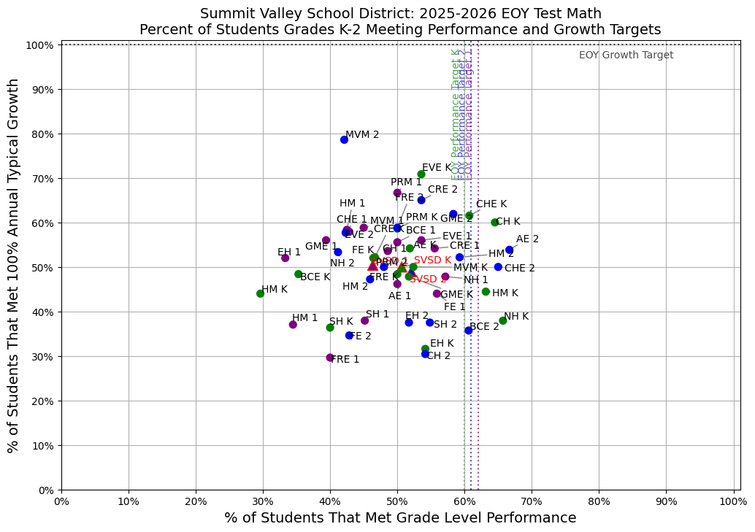
MATH 3-5 |  | BOY | MOY | EOY | EOY Target
GRADE 3 | % Met Grade Level Performance | 37% | 44% | 50% | 53%
 | % Met Annual Typical Growth | N/A | 43% | 49% | 100%
GRADE 4 | % Met Grade Level Performance | 33% | 40% | 46% | 55%
 | % Met Annual Typical Growth | N/A | 46% | 52% | 100%
GRADE 5 | % Met Grade Level Performance | 37% | 45% | 50% | 52%
 | % Met Annual Typical Growth | N/A | 44% | 50% | 100%
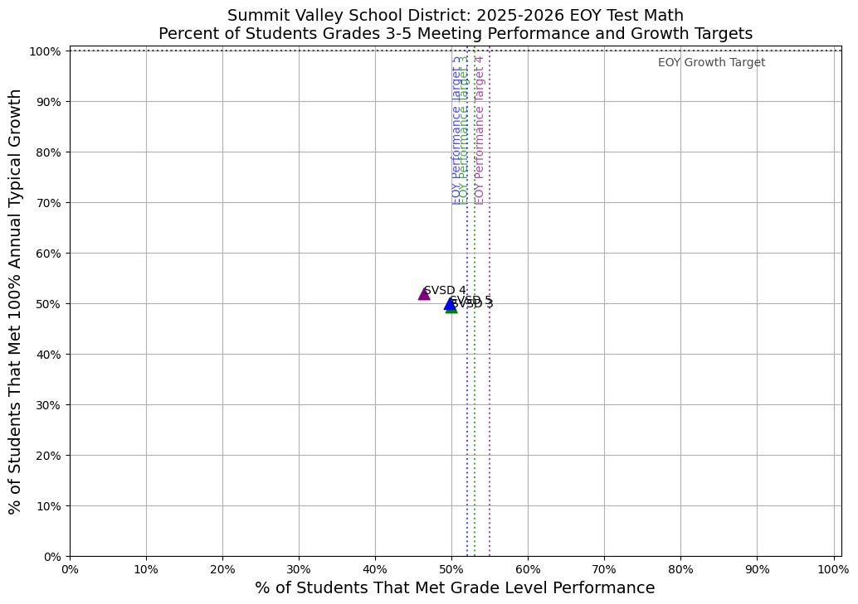
 | Students Met Grade Level Performance (n) | Eligible Students for Performance (n) | Students Met Grade Level Performance (%) | Students Met 100% Annual Typical Growth (n) | Eligible Students for Growth (n) | Students Met 100% Annual Typical Growth (%)
SVSD 3 | 203 | 406 | 50% | 179 | 364 | 49%
SVSD 4 | 201 | 433 | 46% | 187 | 361 | 52%
SVSD 5 | 225 | 452 | 50% | 195 | 391 | 50%
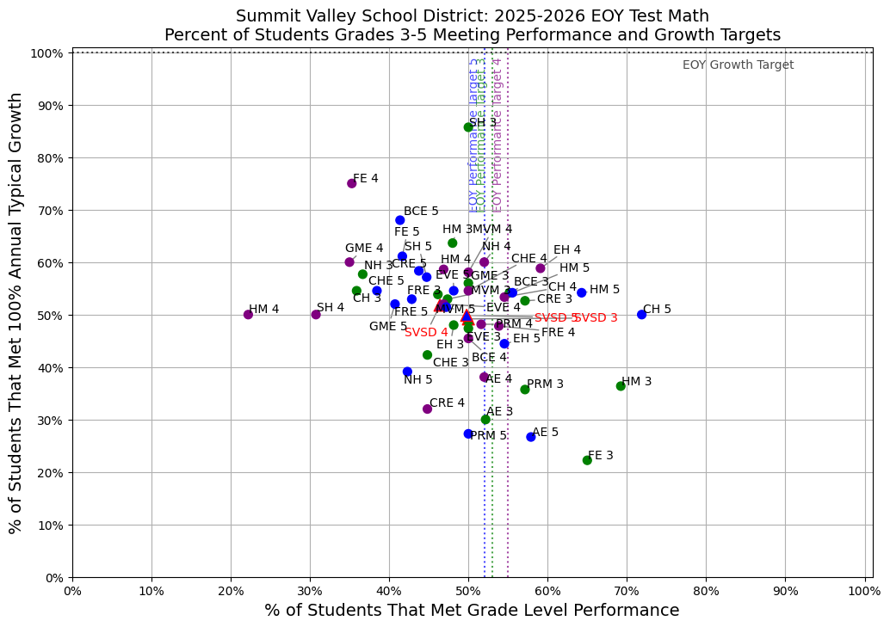
MATH 6-8 |  | BOY | MOY | EOY | EOY Target
GRADE 6 | % Met Grade Level Performance | 32% | 39% | 45% | 54%
 | % Met Annual Typical Growth | N/A | 41% | 48% | 100%
GRADE 7 | % Met Grade Level Performance | 38% | 45% | 50% | 51%
 | % Met Annual Typical Growth | N/A | 44% | 50% | 100%
GRADE 8 | % Met Grade Level Performance | 35% | 42% | 48% | 53%
 | % Met Annual Typical Growth | N/A | 47% | 53% | 100%
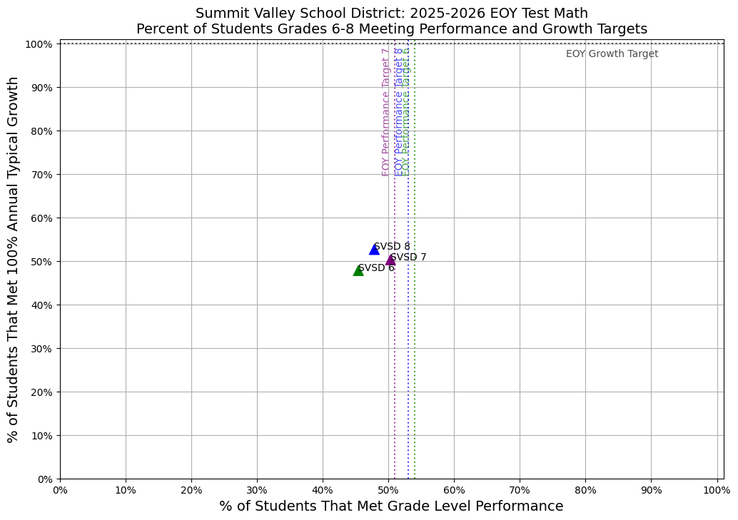
 | Students Met Grade Level Performance (n) | Eligible Students for Performance (n) | Students Met Grade Level Performance (%) | Students Met 100% Annual Typical Growth (n) | Eligible Students for Growth (n) | Students Met 100% Annual Typical Growth (%)
SVSD 6 | 199 | 438 | 45% | 182 | 381 | 48%
SVSD 7 | 229 | 455 | 50% | 200 | 398 | 50%
SVSD 8 | 212 | 443 | 48% | 201 | 382 | 53%
